Papers written by Australian Maths Software

SEMESTER ONE

MATHEMATICS SPECIALIST
REVISION 3
UNIT 3

2016

SOLUTIONS

Section One
1. (6 marks)
(a) (i)
✓
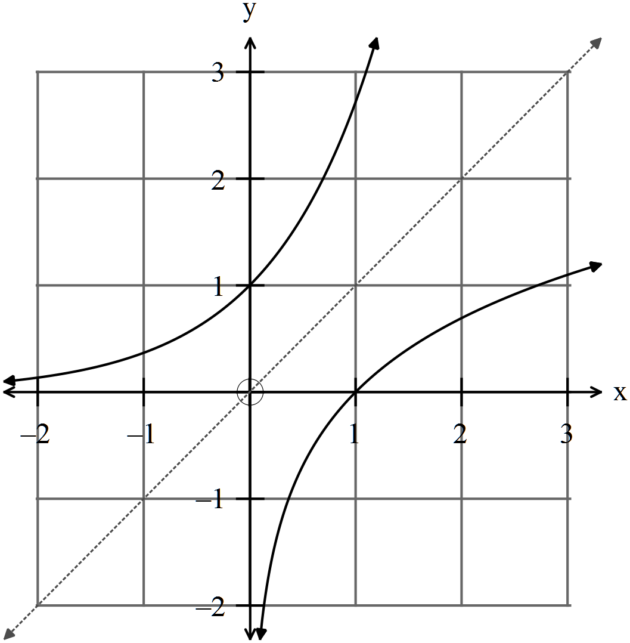
(1)
(ii) 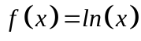 ✓
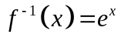 ✓ (2)
✓
(iii) ✓ (2)
(iv) If 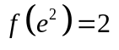then 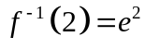 ✓ (1)
2. (10 marks)
(a) 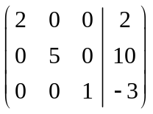
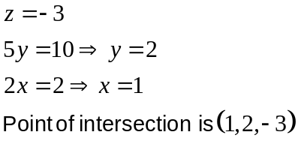
✓
(1)
(b) 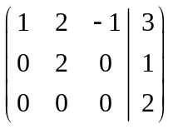
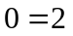 No solution ✓
Two or three of the original planes could have been parallel OR the lines of
intersection of any two of the planes are parallel. ✓ (2)
(c) 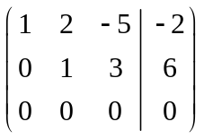
0 = 0 An infinite number of solutions. ✓
Two of the planes could be identical and intersect the third plane or the
three planes intersect in one line. ✓ (2)
(d)
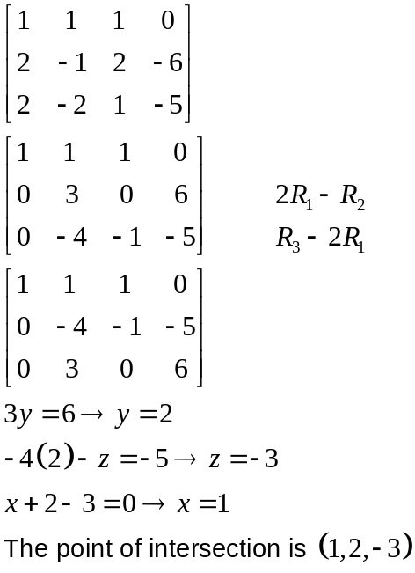
✓
✓
✓
✓
✓
3. (8 marks)
(a) (i) 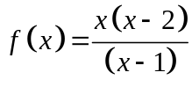 ✓ (1)
(ii) 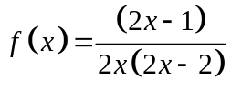 ✓✓✓ (3)
(iii) ✓✓✓✓ (4)
4. (13 marks)
✓
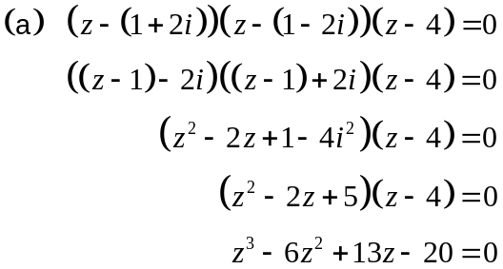
✓
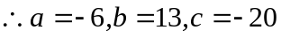 ✓ (3)
(b) 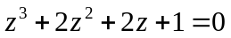
Using synthetic division with 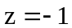 You can use long division but slower
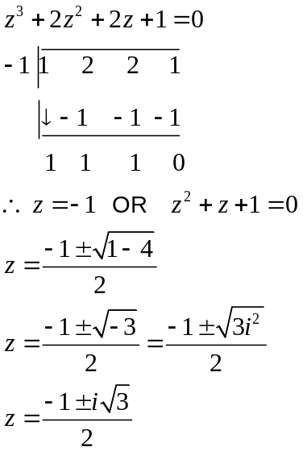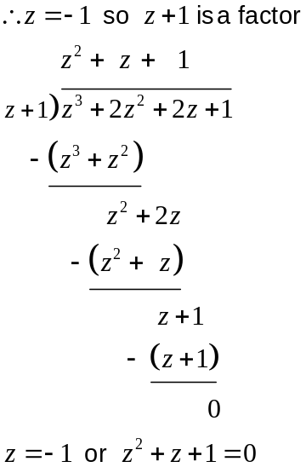
✓
✓
✓ method
✓

(c) (i) 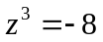
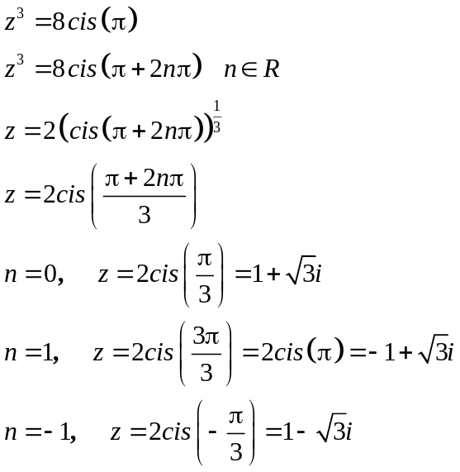
✓
✓✓ -1/error

(3)

(ii) The roots are 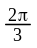apart around the origin. ✓ (1)

(iii)
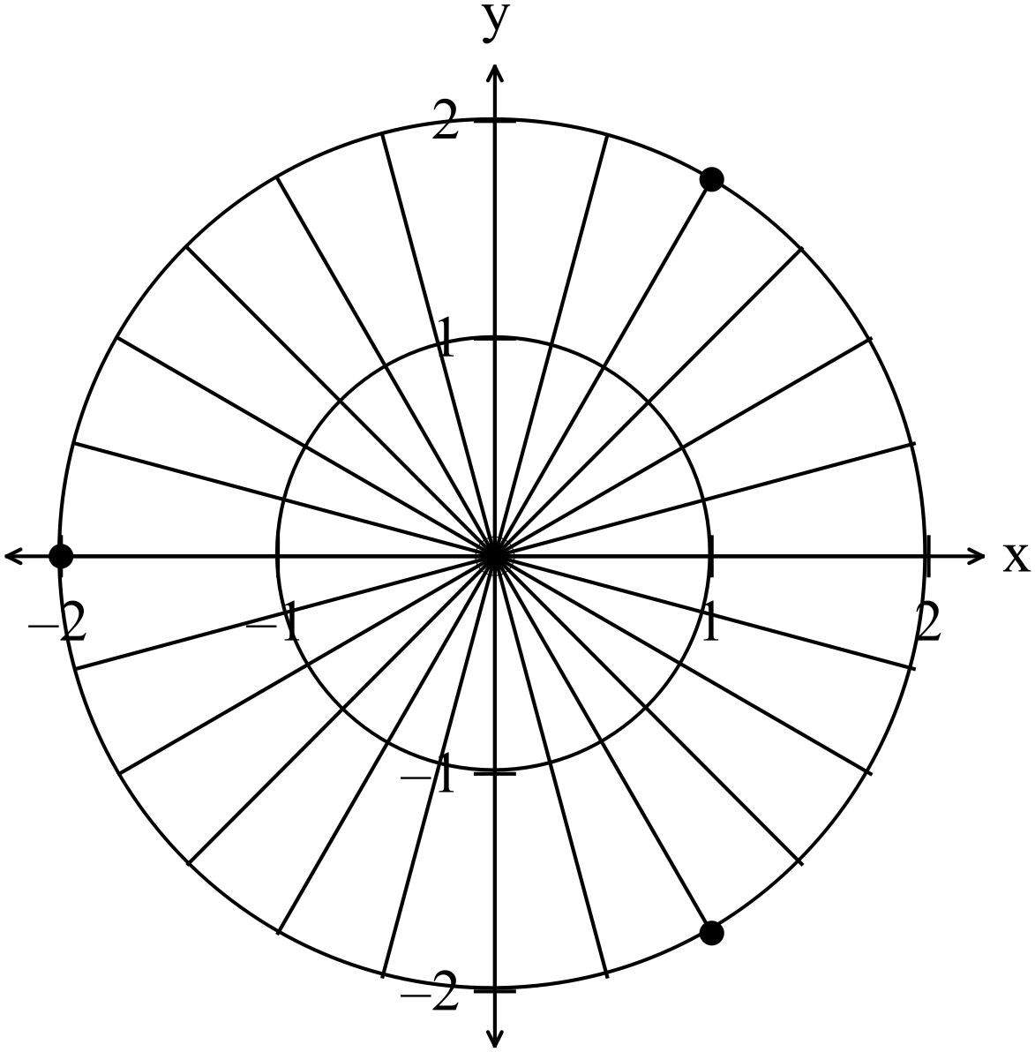
✓✓ -1 per error
(2)

5. (13 marks)
(a) 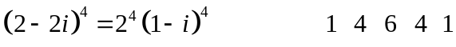 (1)
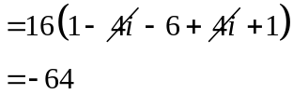
✓

(b) 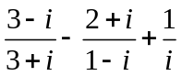
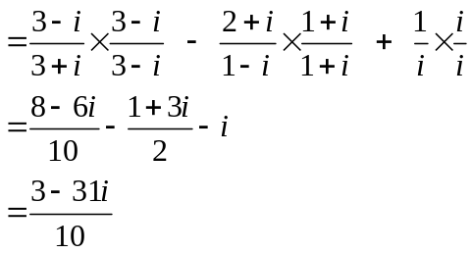
✓
✓
✓
(3)

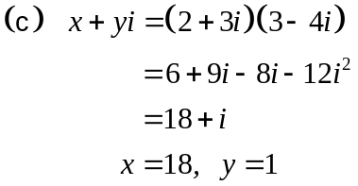
✓ ✓ (2)

(d)
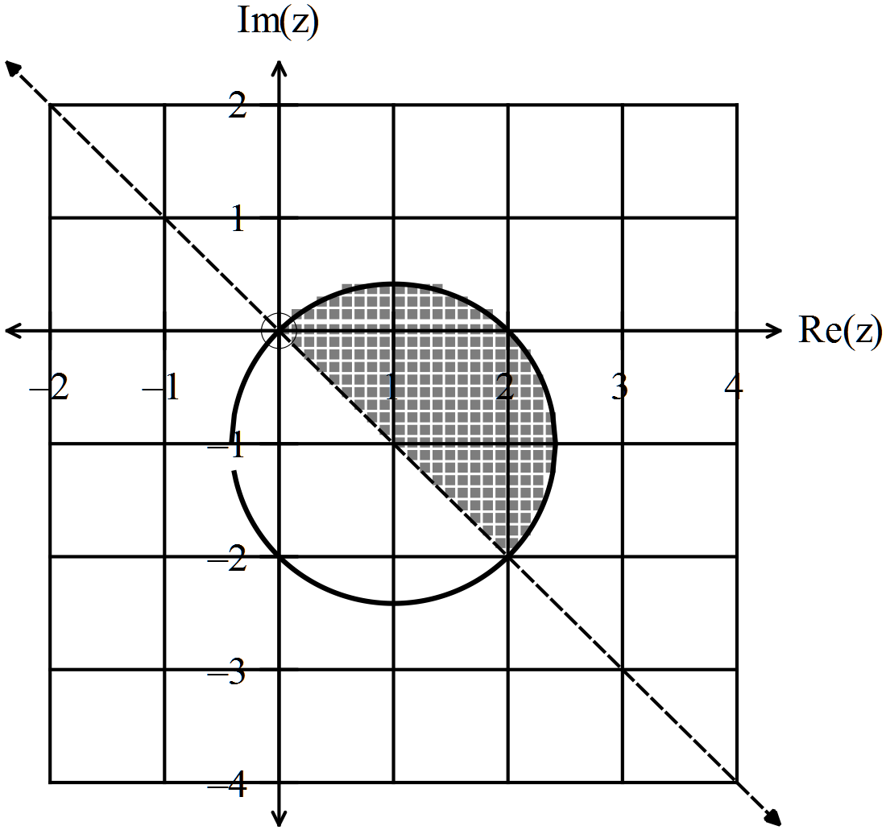
✓
✓
-1 per error

(2)

(e)
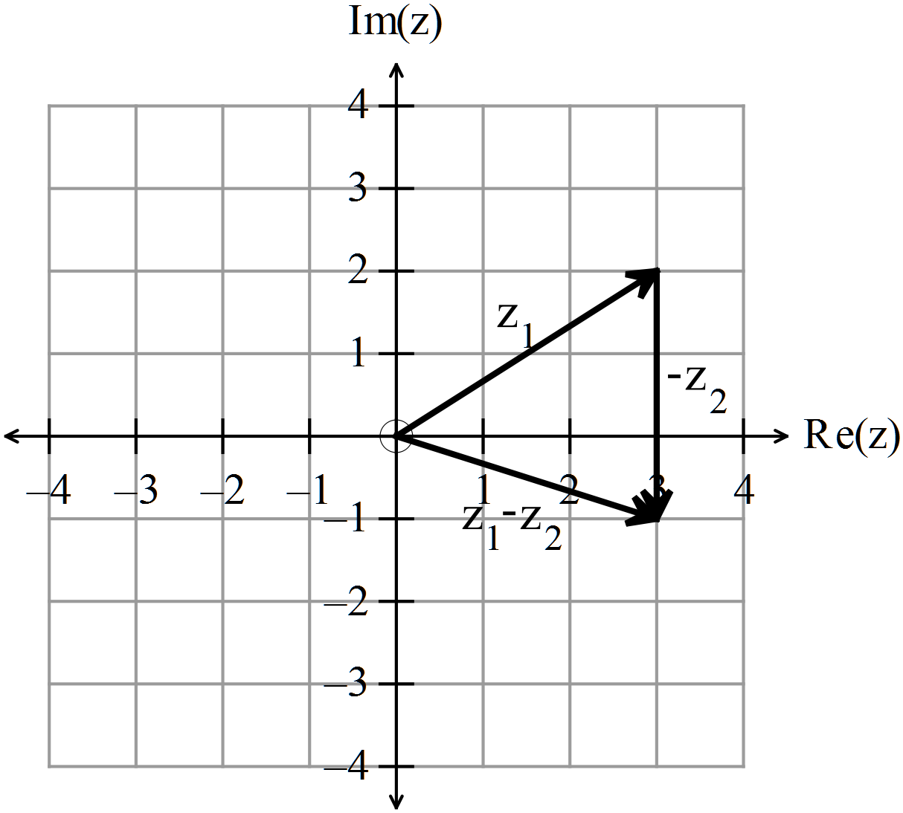
✓✓

(2)
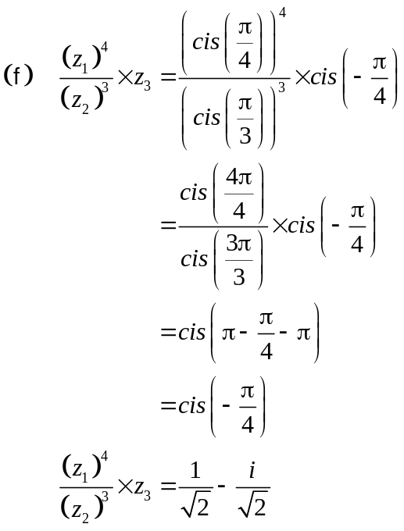
✓
✓
✓
(3)

END OF SECTION ONE
Section Two
6. (19 marks)
(a) (i)
✓

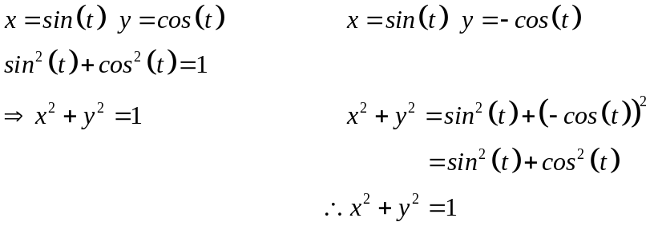
✓

✓

✓

(5)
(ii)
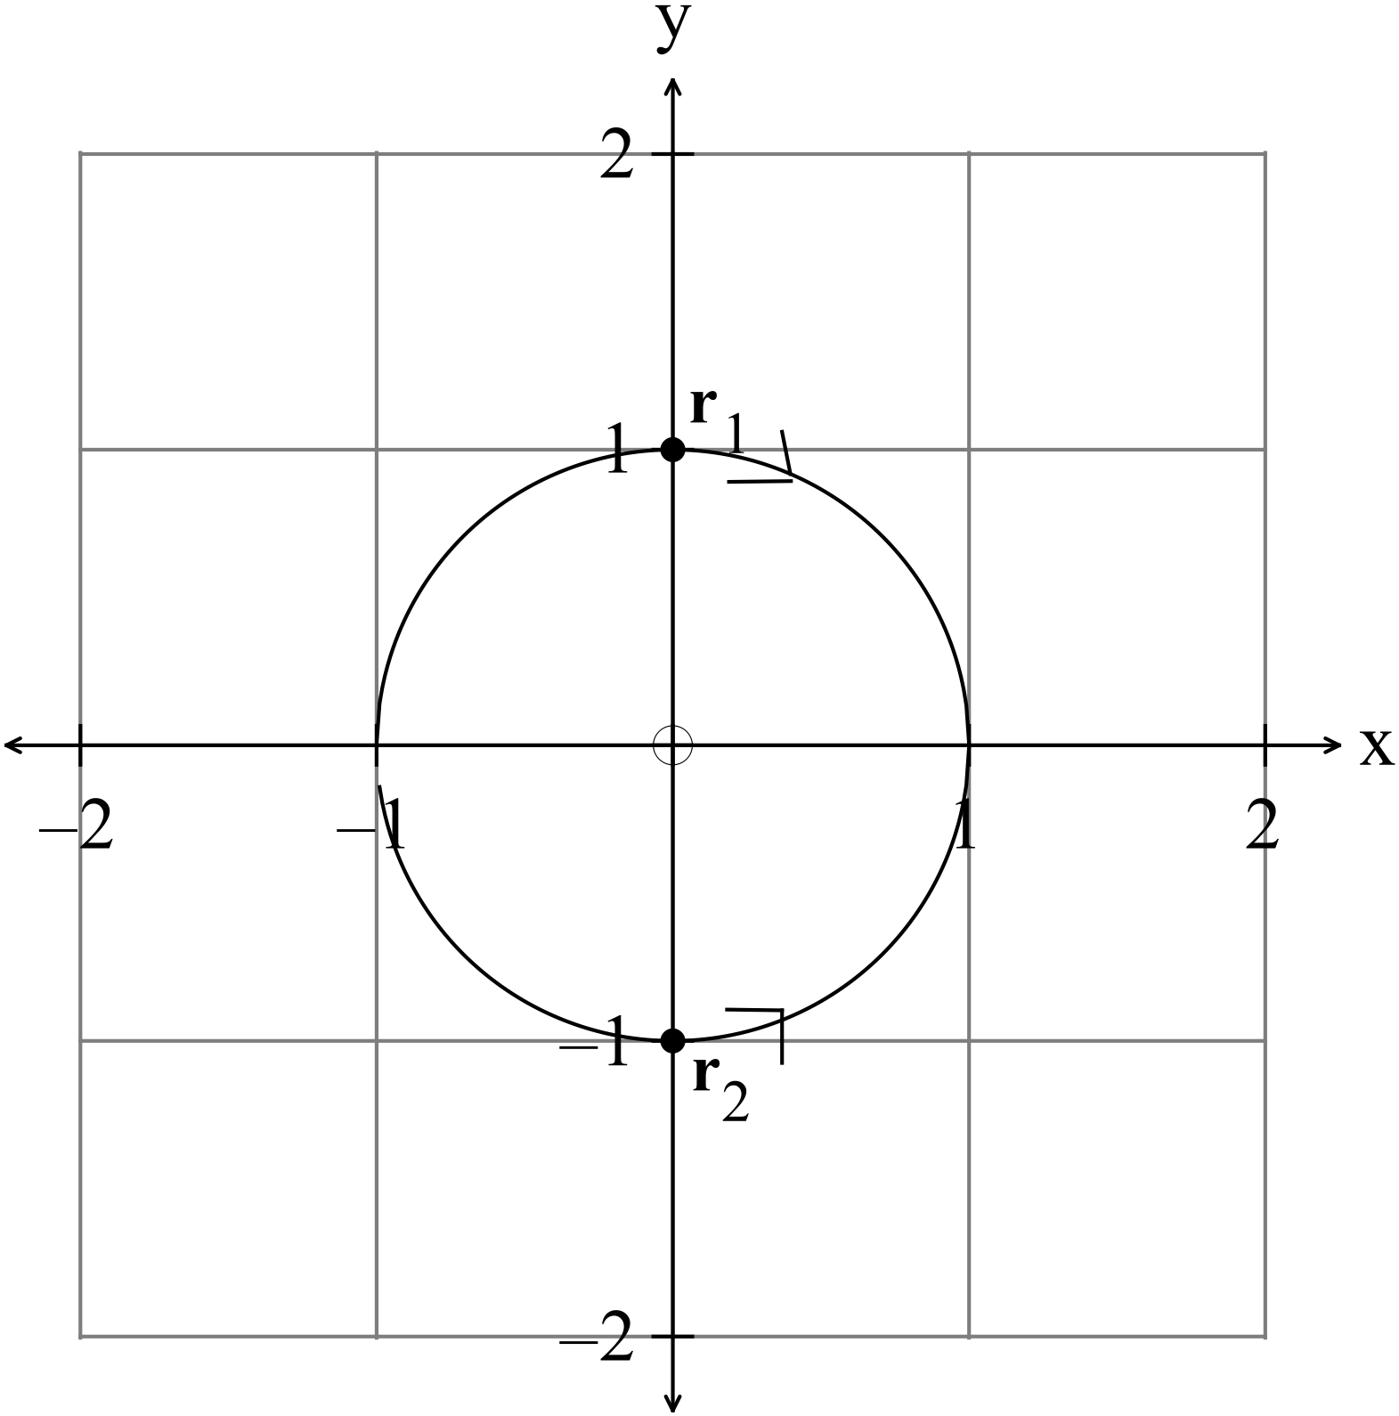
✓✓

✓

✓

(2)

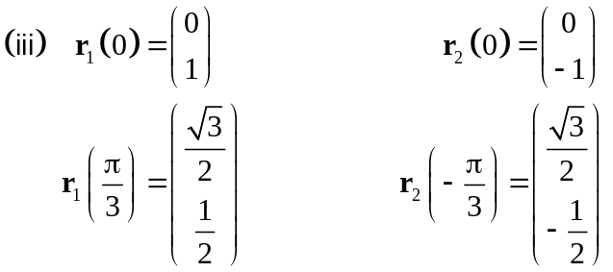 See diagram (2)
(iv) 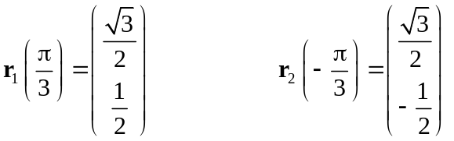
Distance apart is 1 unit. ✓✓ (2)

(b) (i)
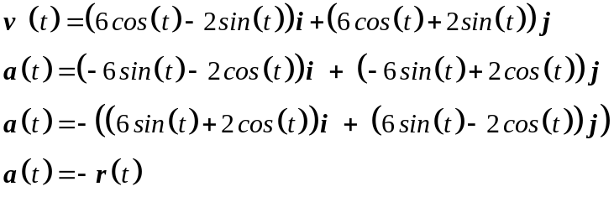
✓✓

✓

✓

(4)
(ii) 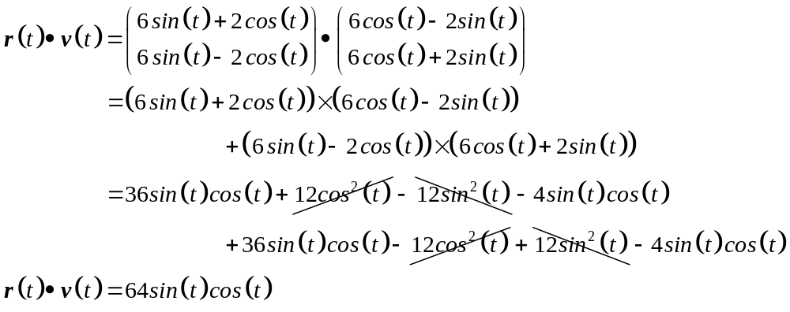
✓

✓

✓

(3)
(iii) If 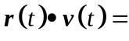0 then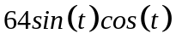=0
✓

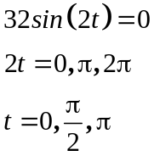
✓

(3)
7. (7 marks)
(a) 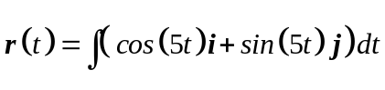
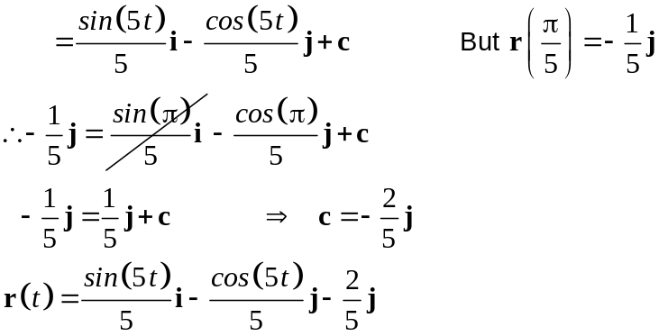
✓

✓

✓

(3)

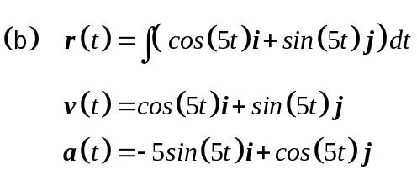
✓

✓

(2)
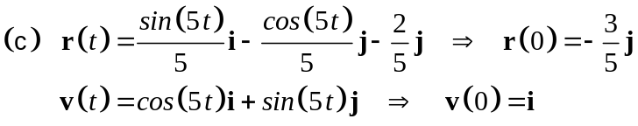
✓

✓

(2)
8. (3 marks)
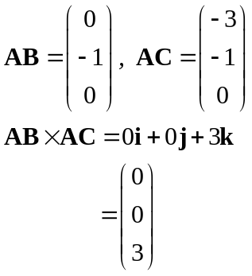
✓

✓

Therefore the unit vector required is 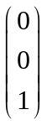 (3)
✓

9. (6 marks)
(a)
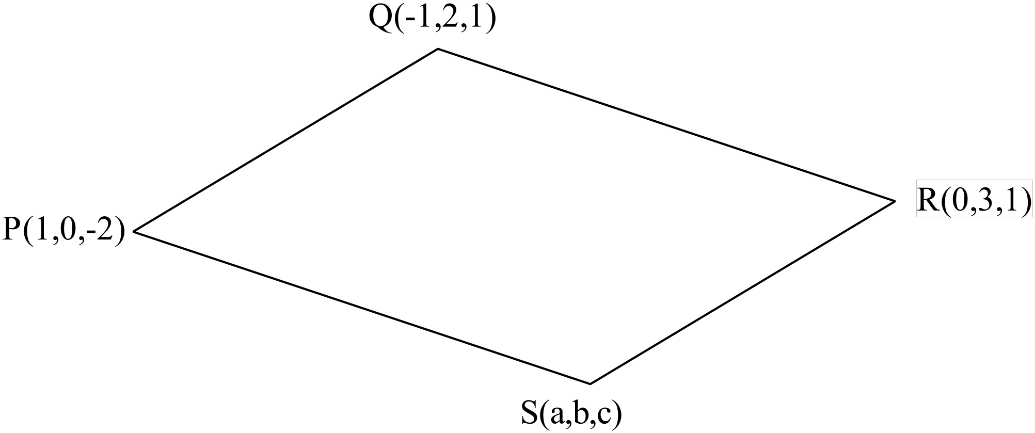
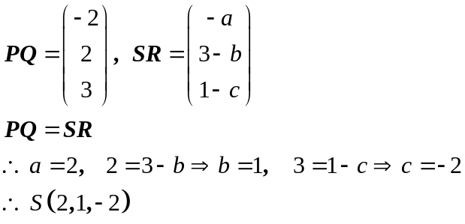
✓

✓✓

(3)
(b) (i) 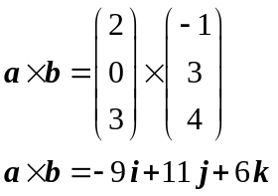
✓

(1)
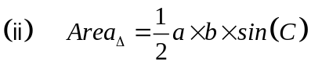
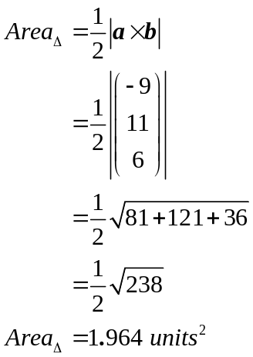
✓

✓

as 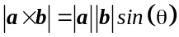 where is the angle
between 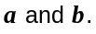

10. (7 marks)
(a) (i) Use 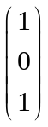 to find vector between P(1,0,1) and 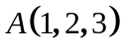.✓
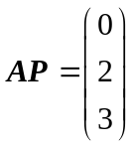 ✓
Equation of plane is 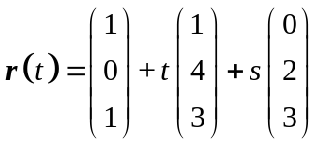 ✓ (3)
(ii) Test 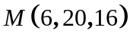
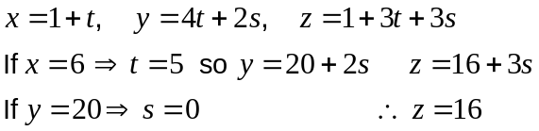
Yes, the point belongs to the line. ✓ (1)

(b) (i) John:
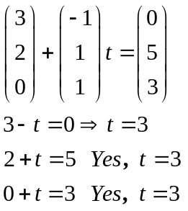
John takes 3 seconds to reach the parcel. ✓ (1)
(ii) James:
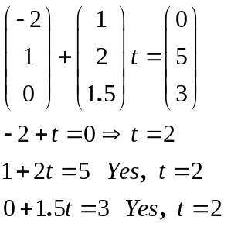
James takes 2 seconds to reach the parcel so he gets to
the parcel first. ✓ (1)

(iii) John: James
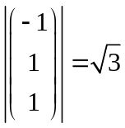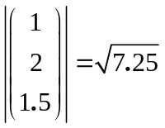
James moves with the greater speed. ✓ (1)
11. (6 marks)
(a) 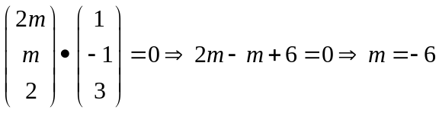
✓

✓ ✓ (2)
(b) (i) 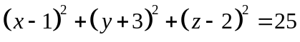
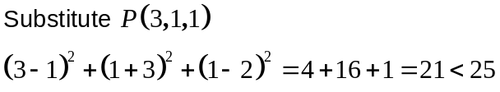 ✓
The point is INSIDE the circle. ✓ (2)

(ii) 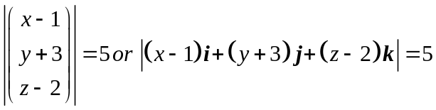 ✓✓ (2)
12. (6 marks)
✓

(a) 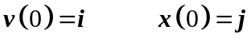
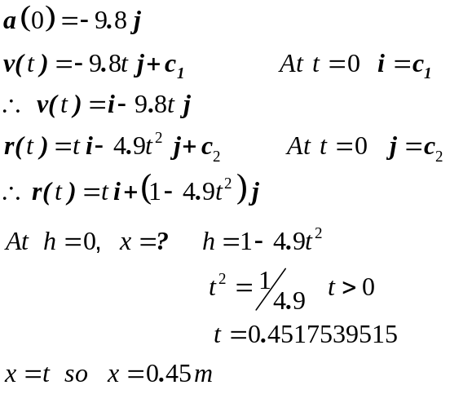
✓

✓

✓

✓

The ball hits the floor 0.45 m from the table. (5)
(b) The ball took 0.45seconmds to hit the floor. ✓ (1)

13. (12 marks)
(a) 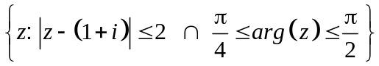 ✓✓✓ -1/error (3)

(b) 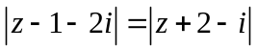 (1,2) (-2,1) midpoint is (-0.5,1.5)
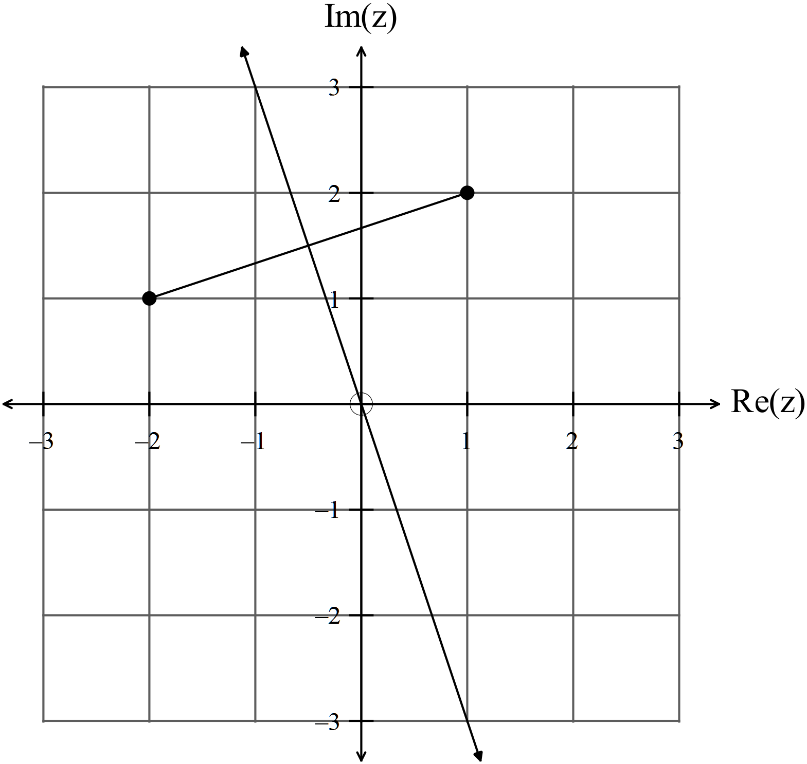
✓✓✓ (3)
(c) (i) 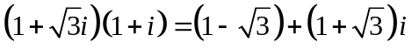 ✓ (1)
(ii) If 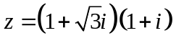 show that 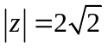 and 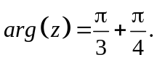
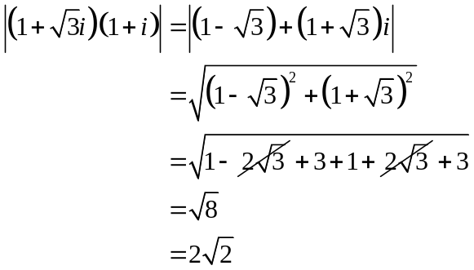
✓

✓

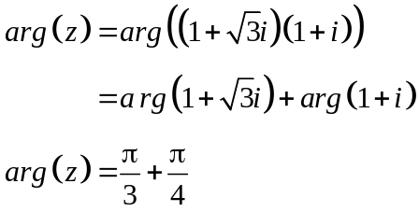
✓

(3)
(iii) Show that 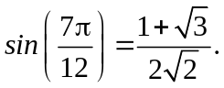
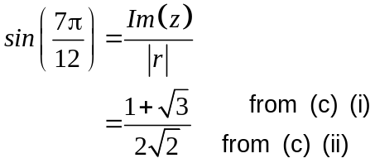
✓

✓

(2)
14. (17 marks)

(a) (i) The inverse exists because the function is a one to one functions so
for every x value, there is a unique and different y value. ✓✓ (2)
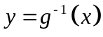
(ii) (2)
✓

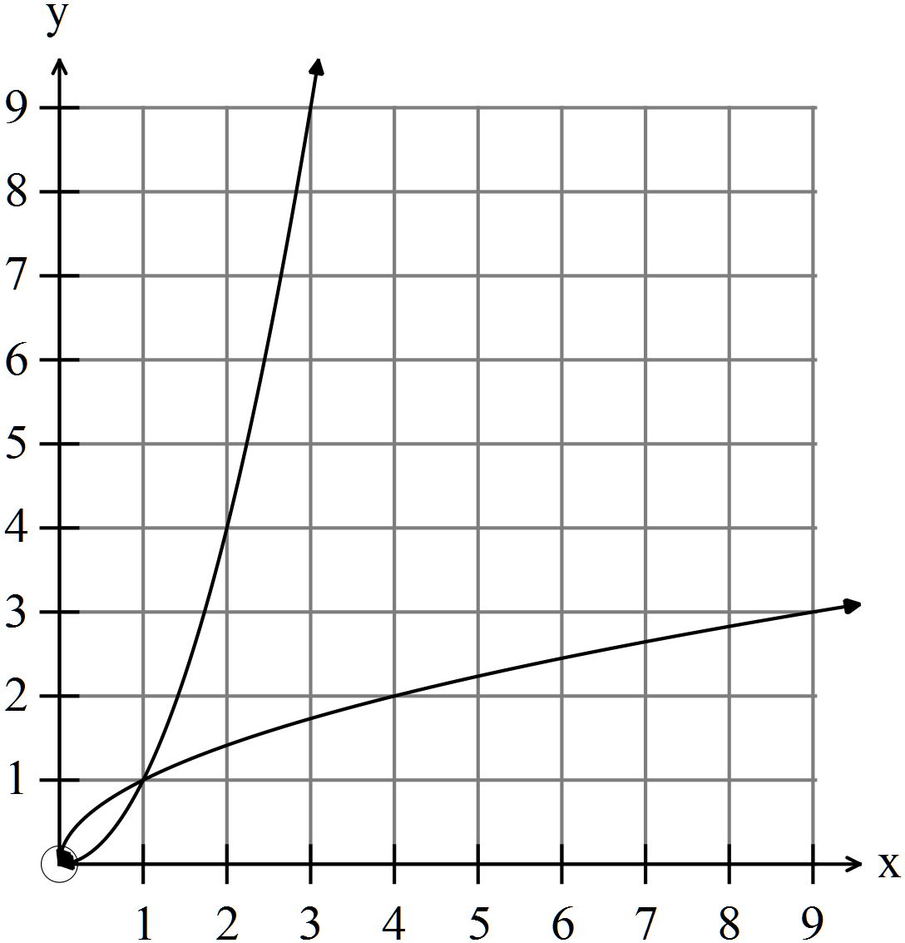
✓

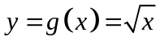
(iii) ✓✓ (2)
(iv) 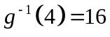 ✓ (1)
(b) Show that 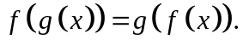
✓

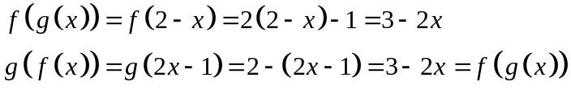
✓

(2)
(c) (i) 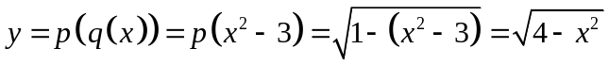 ✓ ✓
Which is defined for 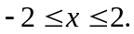 ✓ (3)
(ii) 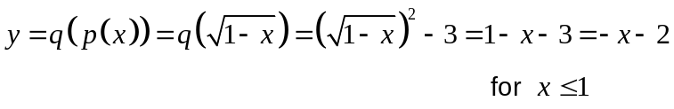 ✓ ✓
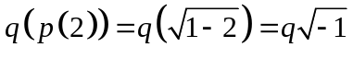 which is not defined. ✓ (3)
(iii) The range of 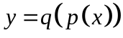 is 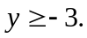 ✓✓ (2)

15. (8 marks)
(a) (i) x = 1 or x = -1 ✓ (1)
(ii) 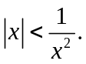
✓

✓

(2)

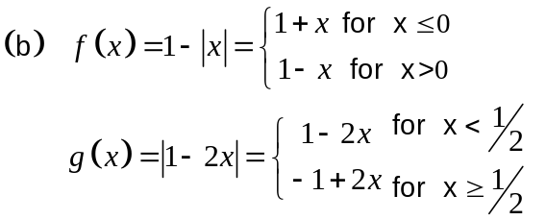
✓

✓

✓

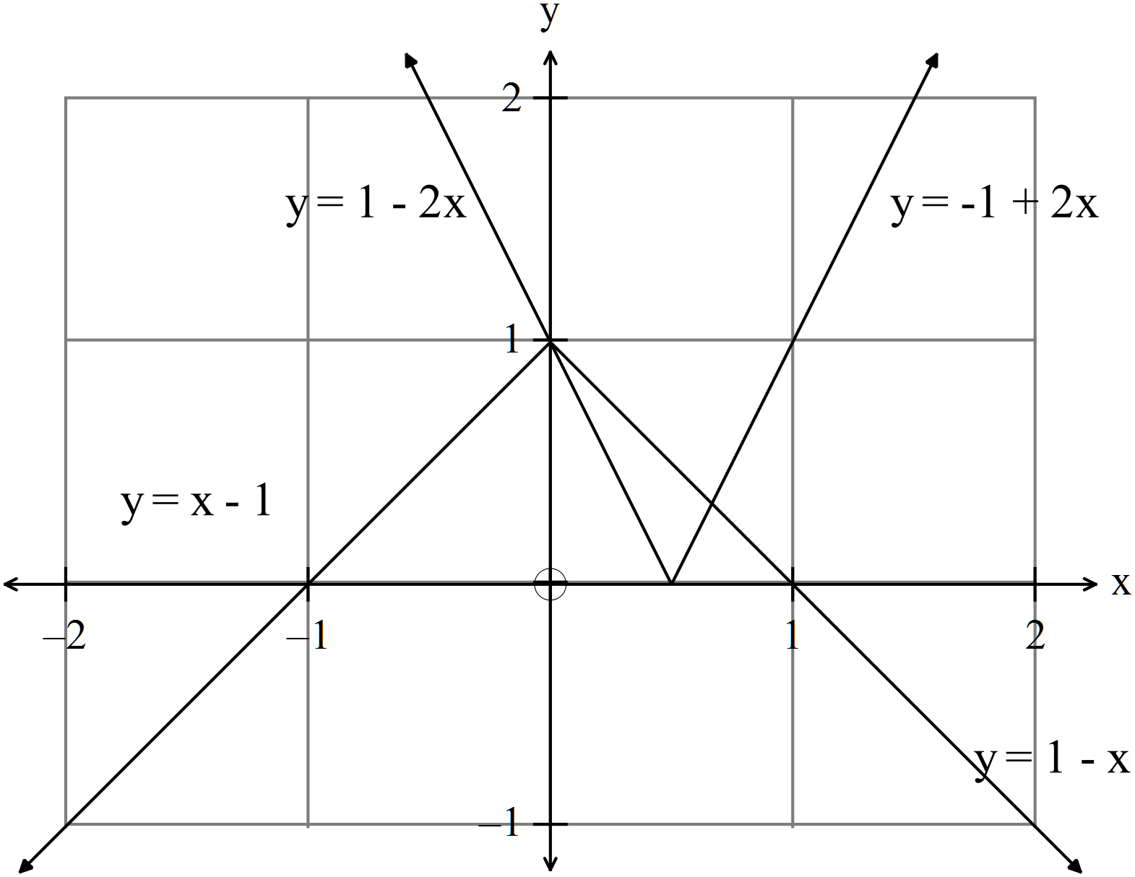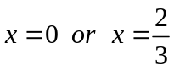
✓

✓

(5)
16. (4 marks)
✓

✓

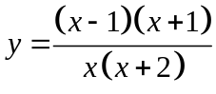 (4)
✓

✓

17. (5 marks)
Prove that .
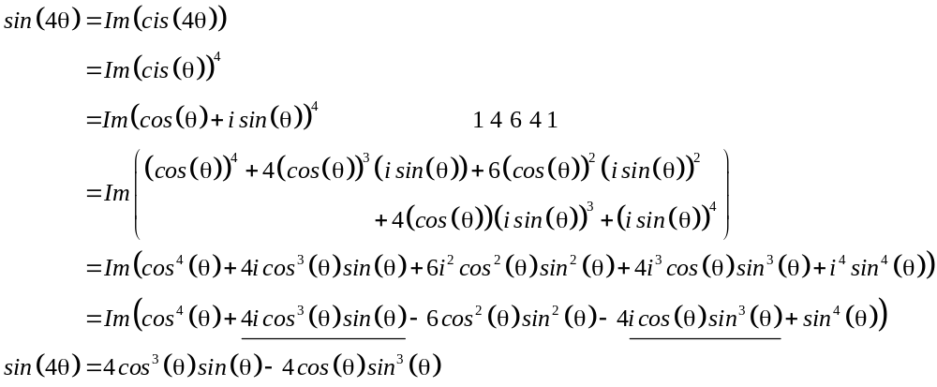
✓

✓

✓

✓

✓

(5)

END OF SECTION TWO

